International Traveling Scholarship Endourological Society
Summary Report, October 2018

Name : Dr Widi Atmoko
Position : Junior Consultant Urologist, Clinical Lecturer, Cipto Mangunkusumo
National General Hospital, Faculty of Medicine, Universitas Indonesia
Host of Institution :
- Stevan Streem Center for Endourology & Stone Disease, Glickman Urological & Kidney Institute, Cleveland Clinic under the supervision of Dr Manoj Monga
- Duke Comprehensive Kidney Stone Center, Duke Urology Clinic, Duke University Medical Center under the supervision of Dr Glenn Preminger and Dr Michael E. Lipkin (and Dr Michael N Ferrandino as Program Director)

Introduction
First and foremost thank you to Endourological Society for giving me the possibility to spend two weeks at Cleveland Clinic and two weeks at Duke University Medical Center. The purpose of my staying was to gather more experience in medical management of kidney stones and the advancement of surgical aspects of nephrolithiasis (development of percutaneous and ureteroscopic techniques, novel endourologic devices). I decided to visit two centers so that I can get the variation of knowledge from different great center.

At Stevan Streem Center for Endourology & Stone Disease, Glickman Urological & Kidney Institute, Cleveland Clinic
At the first day, The Center of International Medical Education of Cleveland Clinic held the orientation for all of the international fellow from all of departments who want to do preceptorship in Cleveland Clinic. It was great experience because we can know the overview of Cleveland Clinic (history, achievement, what you can and can’t do list as international fellow, Cleveland Clinic map, and tips to be safe in Cleveland). After that, all of the international fellow were invited by the organizer to walk around in Cleveland Clinic. At the end of orientation, we were delivered to our destination of department. Then, I met Debbie Denos as secretary of Dr Manoj Monga. I got the schedule of my preceptorship for the next two weeks. The process of orientation was very smooth and perfect.
Through guidance and close tutoring by Dr Manoj Monga I could widen my knowledge in medical management and surgical aspects of endourology of urinary stones. I got the opportunity to observe the outpatient clinic and the operating room under guidance of Dr Manoj Monga. By observing Dr Manoj Monga at the outpatient clinic, I could increase not only my theoretical knowledge but also get acquainted with the art of best communicating with patients suffering from urinary stone. From this clinic setting, I could get the knowledge about how to give the options of treatment, how to explain the chance of stone free rate from each of option, and how to educate about the prevention and medical treatment for kidney stone. At the operating room, I studied the endoscopic-guided access in PCNL with prone split-leg position. He always prefer to do access directly to the upper pole kidney. With this access, we can do the kidney stone surgery through most all of the calyx. Besides that, by doing endoscopic-guided access we can make sure that the access is on the right direction (to papilla renal which is less vascularized) and we can see the dilation directly so that it can reduce the bleeding from doing overdilation or wrong access. He taught me to do the stone surgery to clean all of the stone as possible. So, not only used nephroscope during PCNL, but also he used flexible cystoscope to clean all the stone in the kidney and used flexible ureteroscopy from antegrade to see and evacuate the stone if there was any remaining stone which moved from kidney to ureter. And, the prone split-leg position also have the benefit that we can access the urinary tract both from retrograde and antegrade access. This technique was relatively new for me because most of Indonesian urologists used either pure prone or supine position and used fluoroscopic guided and usually used only nephroscope to crush/evacuate the stone, although some big centers in Indonesia already have flexible cystoscope and flexible ureteroscope. Although this technique requires many high technology instrument of endourology and exercise to apply the prone split-leg position, I think urologist in Indonesia can try to catch up this standard of technique.

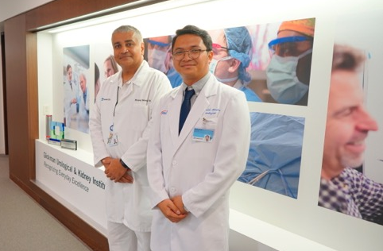

At Duke Comprehensive Kidney Stone Center, Duke Urology Clinic, Duke University Medical Center
In this center, I got the schedule from Dr Michael N Ferrandino as the program director. He arranged all of my activity during my visit. The secretary Janet Nichols, the urology resident Dr Ashley Johnston, the urology Fellow dr RusselI Terry, and nurse practitioner Sarah Yttri always help me in my daily activity in the hospital. I got the chance to study the practice at outpatient clinic and at operating room with Dr Glenn Preminger and Dr Michael E Lipkin. At outpatient clinic, Dr Glenn Preminger showed me the holistic approach for giving the medical management of kidney stone and how to give the education of this management to the patient. There were so many cases in his clinic with this kind of knowledge so that I can grab how to apply this knowledge based on theoretical book/guideline that somehow was hard to understand. I studied from him that not all of the kidney stone need the surgery. It depends on many factors that we should evaluate from the condition of patient. But we need to keep an eye on this case and we can give medical management to prevent the stone growth. I also studied the new imaging system to evaluate urinary stone. They used Digital Tomosynthesis which is a new X-ray-based imaging technique that allows image enhancement with minimal increase in radiation exposure. Digital Tomosynthesis appears to be an ideal alternative for following patients with nephrolithiasis due to its acceptable stone detection rates, low radiation exposure, and decreased cost compared to NCCT. In operating room, I can see the PCNL technique with some variation if I compare to Cleveland Clinic. Dr Glenn Preminger also used endoscopic-guided access PCNL in prone split-leg position and always use superior calyx as the place of puncture except in some situations such as if the location of upper calyx is upper than 11th rib. He used ultrasound lithotriptor and combined it with lasertripsy with flexible cystoscope/urethroscope. Dr Michael E Lipkin used both flouroscopic-guided access and endoscopic-guided access in PCNL but it depends on the condition/stone formation on the patient. I also studied about the advancement technology in Laser Endourology. I studied how to choose the best setting parameter of laser (such as, frequency, energy, pulse duration) and the advantages of new technology Moses laser.

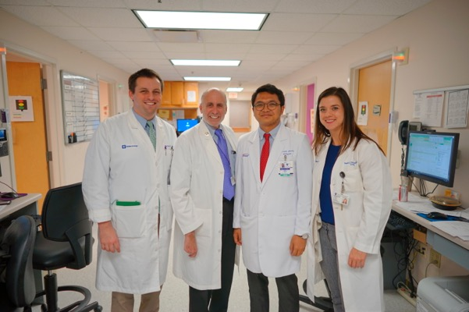

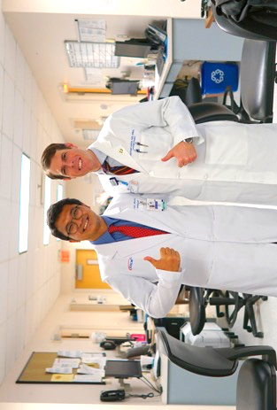

Acknowledgements
I thank the Endourological Society for creating this program and I hope that this program can be sustained in order to make young urologist who comes from middle-low income countries can experience the real advancement of knowledge and technology in good endourology center.
A big thank goes to Dr Manoj Monga, Dr Glenn Preminger, Dr Michael E. Lipkin and Dr Michael N Ferrandino who organized a brilliant programme for my four weeks stay. I would also like thank Janet Nichols, Debbie Denos, Dr Ashley Johnston, Dr RusselI Terry, Dr Luay Alshara, Dr Karen Stern, Sarah Yttri, Urology Residents, Urology Fellows, and many other professionals who made my time in Cleveland and Durham memorable.

Remarks
I am pleased to say that my experience was well above my expectations. I was able to spend time in outpatient clinic and operating rooms. The whole experience gave me a wider understanding of medical management of kidney stones and the advancement of surgical aspects of nephrolithiasis (development of percutaneous and ureteroscopic techniques, novel endourologic devices) and how it is different and similar to Indonesia situation. I was able to reflect on differences in management of care and different technique of operation and how it has shaped services in different countries. I feel I am more equipped and more experienced as a Consultant Urologist following my visit to Cleveland Clinic and Duke University Medical Center under ‘International Traveling Scholarship’ by Endourological Society. This will help me to shape the services that I work to deliver better patient care. I have also made contacts with professionals in Indonesia and we will try to improve our services for the patients based on the advancement of technology and the holistic approach especially in kidney stone management.
To be honest, I could not really find any negative aspects in this relatively short, but full of events experience. All in all, it was a very fruitful period and I will surely recommend this opportunity to colleagues and friends. I learnt a lot of new procedures during the programme and cannot wait to implement all that I have learnt during this training. I’m sure that the gained experience will be undoubtedly beneficial for my further professional activity, and recommend all young urologists to participate in the International Traveling Scholarship program.

Best regards,

October 2018

Widi Atmoko MD
International Fellow

