Endourological Society –
2018 Summer Student Scholarship
Final Report

Urethral Modeling for Artificial Urinary Sphincter Testing

---
Michael Tradewell
Advisor: Gerald Timm, PhD

Outline: (Page #)

Urethral Modeling for Artificial Urinary Sphincter Testing

1.0 Introduction (3)

1.1 Creation of a Functional Artificial Urinary Sphincter Implant Tissue Mimic (3)

1.1.A - Image Collection (3)

1.1.B - Lower Urinary Tract 3D Model Generation (4)

1.1.C - Model Printing (6)

1.2 Artificial Urinary Sphincter Model Validation (7)

1.2.A - in vivo Artificial Urinary Sphincter Pressure/Volume Measurements (7)

1.2.B - ex vivo Model Validation (8)

1.3 Conclusion and Next Steps (9)

Acknowledgments (11)

References (12)

Urethral Modeling for Artificial Urinary Sphincter Testing
1.0 Introduction
Urinary incontinence is a common problem in men after prostatectomy. The AMS 800TM artificial urinary control sphincter (AUS) has been the market leader in surgical treatment for iatrogenic urinary incontinence since it was first introduced in the 1970’s. Over 150,000 have been placed. There are limitations to the AMS 800TM: notably stress incontinence and urethral erosion. The development of new AUS devices to solve these problems is imperative. In this project, we set-out to develop an anatomically and mechanically accurate bench-top urethral tissue-mimic model to rapidly and reliably test AUS devices.

  - Creation of a Functional Artificial Urinary Sphincter Implant Tissue Mimic
1.1.A - Image Collection
Creation of a highly accurate digital anatomical model of the male urethra lumen was created from 3D reconstruction of a CT voiding cystourethrogram (CT-VCUG). A CT-VCUG is an imaging technique where the bladder is filled with radio-opaque contrast dye, the patient is placed in a CT scanner and the image is captured while the participant is mid-void. While urethral imaging is common via x-ray voiding cystourethrogram (VCUG), CT imaging studies are rare. It was necessary to use a CT-VCUG because two dimensional VCUG images cannot be recreated into a 3D model and standard CT imaging does not have sufficient contrast (difference in Hounsfield units) between the urethral lumen and surrounding soft tissue. As such, it was necessary to use a CT-VCUG to create the model. After an exhaustive literature search for groups performing CT-VCUG, no American groups were identified. In fact, only seven studies from six groups in China, Taiwan, and Egypt have reported the use of CT-VCUG for research purposes in the literature (1-7). After reaching out to the seven corresponding authors, one graciously shared a CT-VCUG study. CT data was collected under a University of Minnesota IRB approved protocol (STUDY00001777).
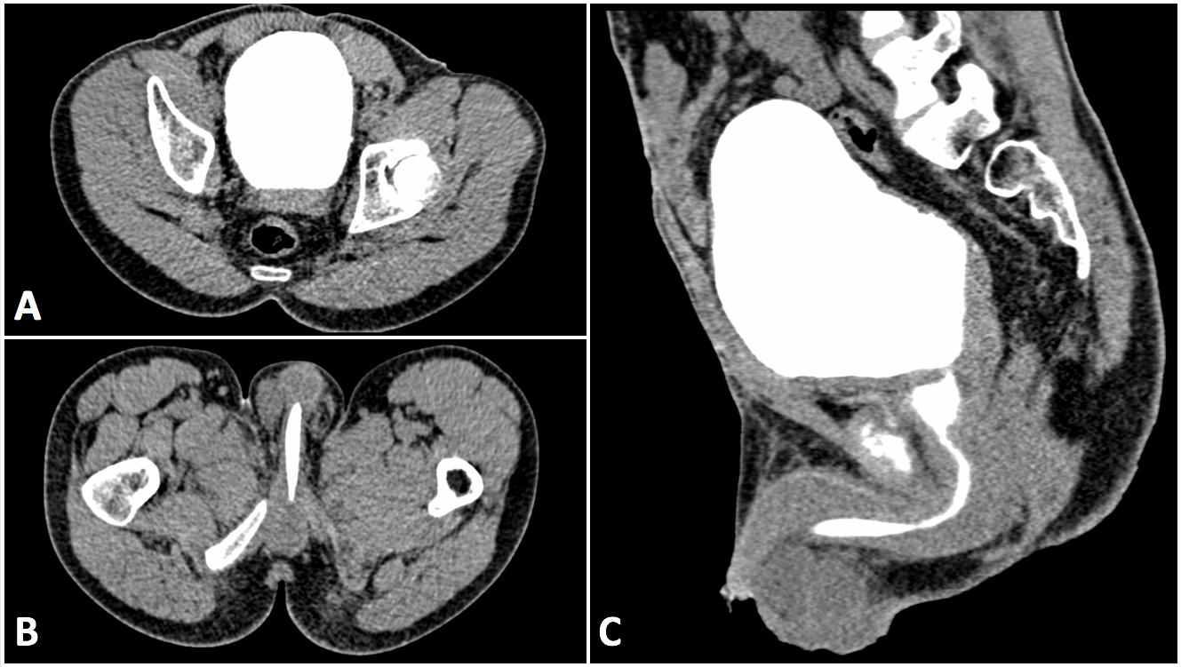
Figure 1 Sections of CT-VCUG study images. Contrast dye within the urine appears bright white on the scan. Axial view through bladder (A). Axial view through bulbar and penile urethra (arrow B). Sagittal view through lower urinary tract (C).

1.1.B - Lower Urinary Tract 3D Model Generation
Using Seg3D (Version 2.4.0, University of Utah, Salt Lake City, UT) a 3D rendering of the urine was created via CT image segmentation (Figure 2A). This gave a highly accurate model of the urethra lumen. Through a sequential series of masks created from different pixel intensity (Hounsfield units) thresholds, Boolean operations, and morphologic operations, a complete lower urinary tract model with a hallow urethral lumen was created (Figure 2D). Two separate mated STL files were created to allow for different mechanical properties of the two tissues in the final 3D printed model: (1) corpora cavernosa and prostate (Figure 2B) and (2) urethra and corpora spongiosum (Figure 2C). A block section of corpora cavernosa was removed around the bulbar urethra to mimic in vivo AUS implant conditions (Figure 2E). The model was smoothed using Meshmixer (Version 3.4, Autodesk, San Rafael, CA).

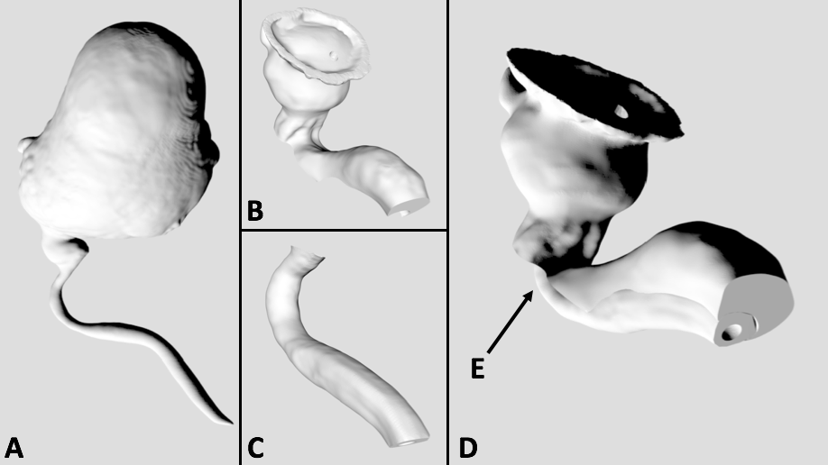
Figure 2 3D Reconstruction for the Lower Urinary Tract via CT segmentation. Urine volume (A), corpora, prostate, and bladder neck (B), sponge and urethra (C), complete lower urinary tract (D), and exposed bulbar urethra segment (E).
1.1.C - Model Printing
The complete lower urinary tract was printed with STRATASYS® BIOMIMICS™ (Stratasys, Eden Prairie, MN). This technology prints with 14µm accuracy in a substrate with mechanical properties similar to soft tissue. Both the corpora and sponge sections of the urethra were printed with the same material. A pocket for the AUS was created within the model using a scalpel. Two identical models were created. The fit and placement accuracy of the AUS cuff was approved by a reconstructive urologist, Sean Elliott, MD, MS.

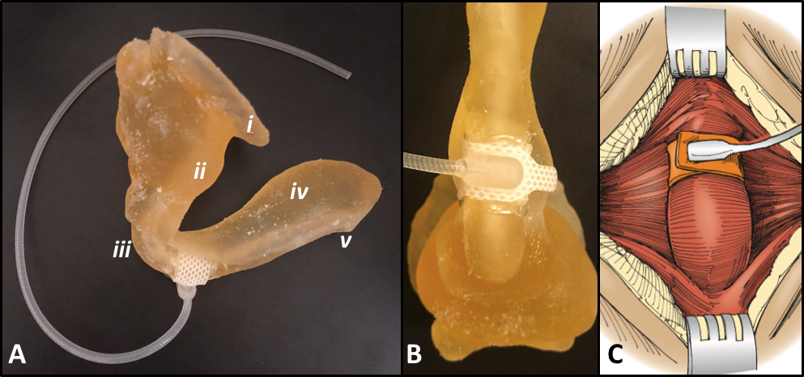
Figure 3 Printed lower urinary tract model with AUS in situ. Prospective view (A), standard bulbar urethra view via perineal approach (B). Comparison of bulbar urethra dissection sketch reproduced from Hinman’s Surgical Atlas (C, 8). The lower urinary tract model is complete with a bladder neck (i), prostate (ii), bulbar urethra (iii), corpora cavernosa (iv), and penile urethra (v).
  - Artificial Urinary Sphincter Model Validation
1.2.A - in vivo Artificial Urinary Sphincter Pressure/Volume Measurements
The following methods and data are reproduced, with permission from Mishra (9). Prior to me joining the project, my research lab team completed a small series (n=5) of in vivo AUS cuff (Boston Scientific, Marlborough, MA) pressure/volume measurements. After surgical AUS cuff implementation, the cuff tubing was flushed with saline and a TruWave pressure transducer (Edwards Lifesciences Corporation, Irvine, CA) was connected to the device. Incrementally, 0.1ml of sterile saline was injected into the cuff. After each injection, cuff pressure was measured up to 120 cmH₂O. The AMS 800TM pressure volume curves are shown in Figure 4.

Figure 4 in vivo AMS 800 pressure/volume curves (9).
1.2.B Model Validation
We set out to recreate the in vivo pressure/volume curves recorded inter-operatively. Using two printed models, two 4.5 cm AMS 800TM cuffs, and two pressure monitors in the Visible Heart Lab and a University of Minnesota Fairview Hospital operating room (OR) we reproduced the in vivo pressure/volume measurements (n=2). The AUS cuff was placed around the bulbar urethra section of the model and inflated incrementally with 0.1mL, after each infusion the equilibrated pressure within the system was measured. We stopped inflating the cuffs used in the experimental model after 0.3 mL due to concerns of over inflation.
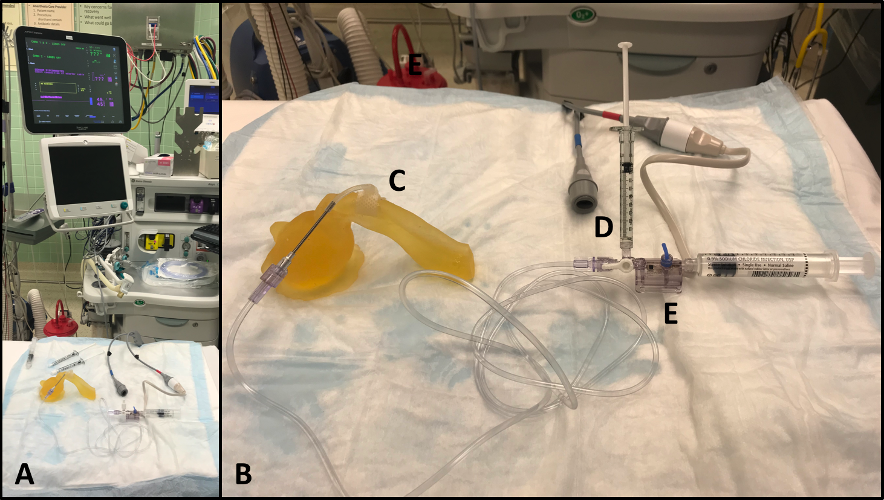
Figure 5 Bench-Top Validation Testing. Full ex vivo experimental set-up with pressure measurement on OR anesthesia system (A). Complete pressure measurement system (B) with 4.5 cm AMS 800TM cuff in situ on printed model (C), 1ml graded syringe for cuff infusion (D), and TruWave pressure transducer (E).
Figure six shows the comparative pressure/volume curved between the in vivo (n=2) and ex vivo (n=2) implanted 4.5cm cuffs. The average cuff pressure at 0.3ml implanted in a patient was 75.48cm H₂O (range 68.00, 82.96 cm H₂O) compared to an average cuff pressure of 226.53 cm H₂O (range 217.72, 234.34 cmH₂O) recorded in the model.
Figure 6 Pressure vs. Volume Profiles of AMS 800TM Occlusive 4.5 cm Cuffs in vivo and ex vivo. Red curves are data from two 4.5 cm occlusive cuffs implanted in patients receiving an artificial urinary sphincter for incontinence. Blue curves are data from cuffs within our printed bench-top model.

  - Conclusion and Next Steps
We set-out to develop an anatomically and mechanically accurate bench-top urethral tissue-mimic model to rapidly and reliably test AUS devices. Using a CT-VCUG and image segmentation techniques we created an anatomically accurate model of the male lower urinary tract. This model was 3D-printed with a high-degree of precision out of a substrate designed to mimic soft tissue properties. To validate our model, we reproduced an clinical study by implanting a AMS 800TM 4.5 cm cuff into the model. Our hypothesis was that if the in vivo pressure/volume curves could be recreated ex vivo we would have a valid AUS test-bench model. Our ex vivo curves exhibited far higher cuff pressures than the in vivo data.

These data suggest two possibilities: the cuff used in the experiment is sized too small for the bulbar urethra model or the model material is stiffer than sponge and urethra tissue. The first hypothesis is unlikely given that the model-cuff fit was assessed by an expert reconstructive urologist who implants AMS cuffs regularly. With regard to the second hypothesis, we have reached the limits of the BIOMIMICS™ printer and are looking to create mechanically accurate models from layered silicone. Through an iterative process of altering the silicone durometer based on cuff pressure measurements we believe we will be able to create an anatomically and mechanically accurate bench-top urethral tissue-mimic model to rapidly and reliably test AUS devices. Once, we have matched the proper mechanical properties we plan to test model continence under typical bladder and cuff pressures as a second model validation measure.

Acknowledgments:
- Dr. Gerald Timm for guidance, grant support, and for being accessible often via phone and email for questions.
- Avishek Mishra for providing in vivo AUS pressure/volume data and helping set-up ex vivo experiments.
- Dr. Chen-Pin Chou for providing a deidentified CT-VCUG scan.
- Dr. Sean Elliott for guidance with AUS placement within the bench-top model and grant support.
Thank you to STRATASYS BIOMIMICS for providing lower urinary tract 3D prints, to Boston Scientific for providing AMS 800TM Urinary Cuffs, and to the Visible Heart Lab and University of Minnesota OR for providing assess to anesthesia machines to collect ex vivo pressure measurements.
I would also like to thank the Endourology Society Summer Student Grant Program for financially supporting the Urethral Modeling for Artificial Urinary Sphincter Testing project.

References:
1. El-Kassaby AW, Osman T, Abdel-Aal A, Sadek M, Nayef N. Dynamic three-dimensional spiral computed tomographic cysto- urethrography: a novel technique for evaluating post-traumatic posterior urethral defects. BJU Int. 2003;92(9):993–6.
2. Zhang XM, Hu WL, He HX, Lv J, Nie HB, Ya oHQ, etal. Diagnosis of male posterior urethral stricture: comparison of 64- MDCT urethrography vs. standard urethrography. Abdom Imaging. 2011;36(6):771–5.
3. Sa YL, Xu YM, Feng C, Ye XX, Song LJ. Three-dimensional spiral computed tomographic cysto-urethrography for post-traumatic complex posterior urethral strictures associated with urethral- rectal fistula. J Xray Sci Technol. 2013;21(1):133–9.
4. Chou CP, Huang JS, Wu MT, Pan HB, Huang FD, Yu CC, et al. CT voiding urethrography and virtual urethroscopy: preliminary study with 16-MDCT. Am J Roentgenol. 2005;184(6):1882–8.
5. Feng C, Shen YL, Xu YM, Fu Q, Sa YL, Xie H, et al. CT virtual cystourethroscopy for complex urethral strictures: an investigative, descriptive study. Int Urol Nephrol. 2014;46(5):857–63.
6. Hanna S, Rahman S, Altamimi BA, Shoman AM. Role of MR urethrography in assessment of urethral lesions. The Egyptian Journal of Radiology and Nuclear Medicine (2015) 46, 499–505.
7. Lv XG, Peng XF, Feng C, Xu YM, Shen YL. The application of CT voiding urethrography in the evaluation of urethral stricture associated with fistula: a preliminary report. Int Urol Nephrol (2016) 48:1267–1273.
8. Hinman's Atlas of Urologic Surgery. Book by Glenn M. Preminger, Joseph A. Smith, and Stuart S. Howards. 2012. ISBN: 9780128016480
9. Mishra A, Elliott S, Timm G. Pressure-Volume Profiles of the Artificial Urinary Sphincter (AMS 800TM) Occlusive Cuff. Abstract. Engineering & Urology Annual Meeting. May 2018. San Francisco, CA.

