Utilization of EMG in Conjunction with Hand Motion Analysis in Developing an Objective Surgical Skill Evaluation in Resident and Attending Surgeons – Progress Report

Daniel Haik, UC Irvine Department of Urology –Dr. Clayman Lab

This progress report will encompass an overview of the development of the study, including a detailed protocol and our EMG data analysis model.

Detailed Protocol:
Lead Placement
The leads are placed as described in the initial protocol, as illustrated below:
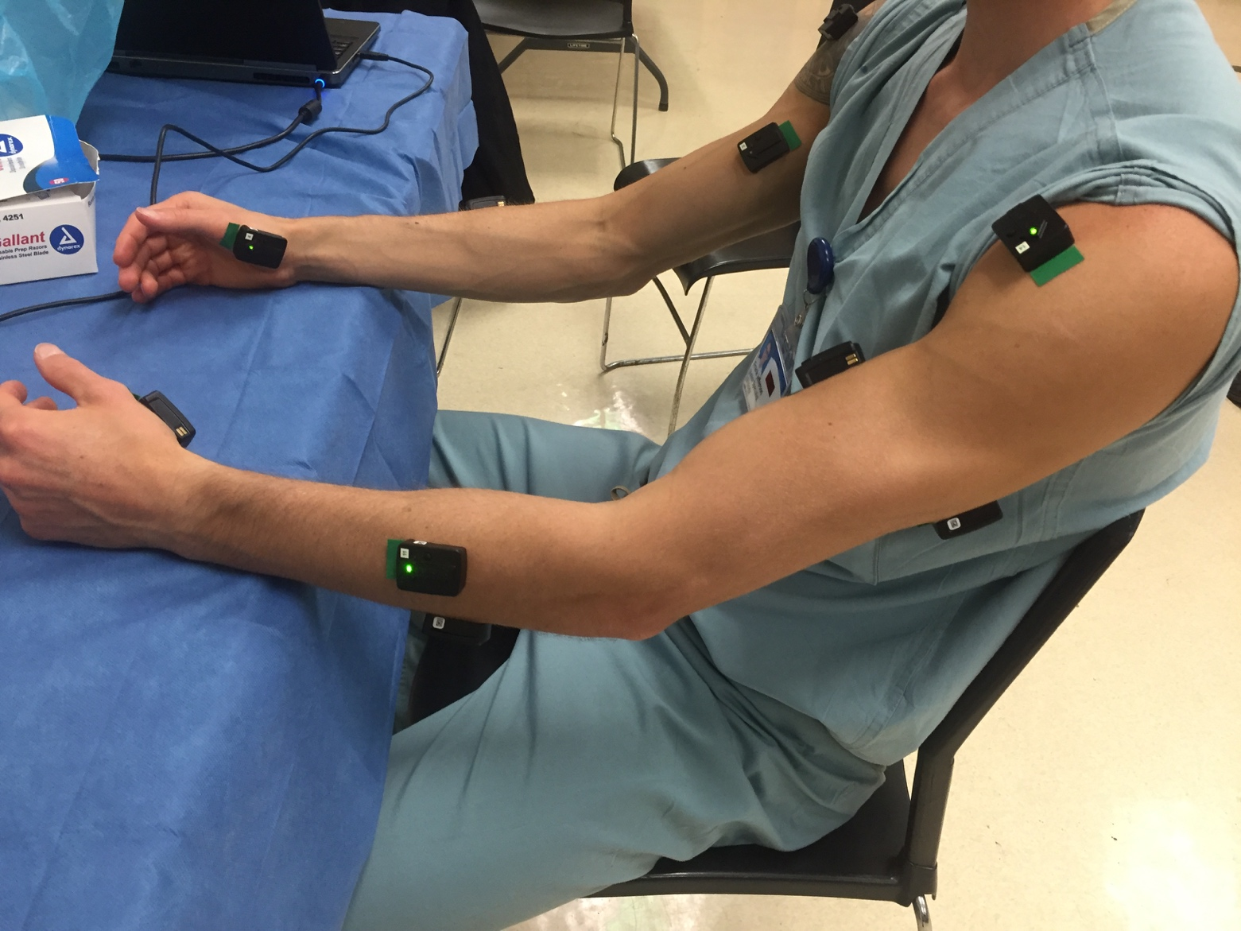
Figure 1. Lead Placement

Calibration
Subjects are calibrated at their resting state, as well as with a maximum voluntary contraction (MVC) for every muscle. An example of an MVC for the biceps brachii is illustrated in the graph below. This ensures that subjects are adjusted for their varying electrical strength in muscle activation.

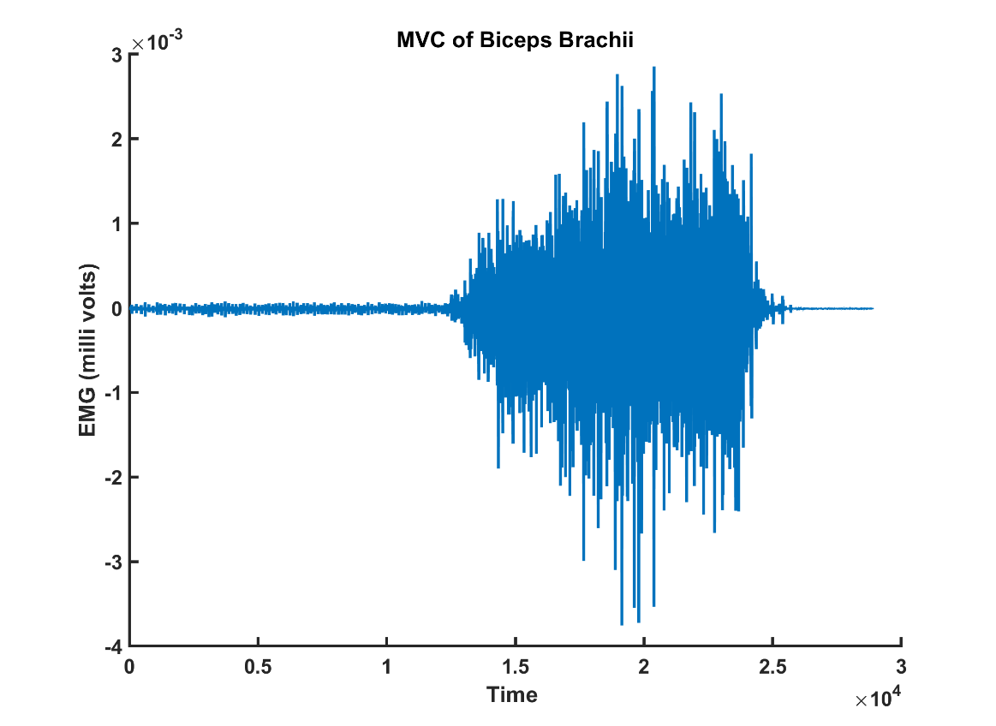

Figure 2. Maximum Voluntary Contraction of Biceps Brachii

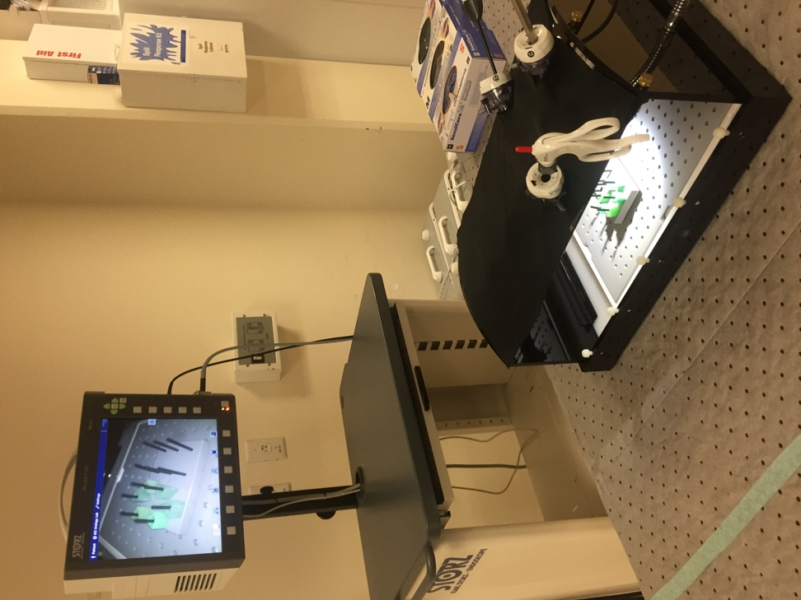
Clinical Skills tasks – Each task is run 3 times
- Laparoscopic Simulation – Peg Transfer:
Apparatus depicted in figure 3. Involves the removal of objects from a peg on one side of a board, transferring midair from one hand to the next, and placement on the other side. Must be repeated for all objects, and then returned to the original side.

- Knot Tying:
Task involves the tying of a surgeon’s knot, followed by three single knots, forming two square knots. An image with data captured from the left and right thenar EMG devices is shown in figure 4.

Figure 3. Laparoscopic Training Device
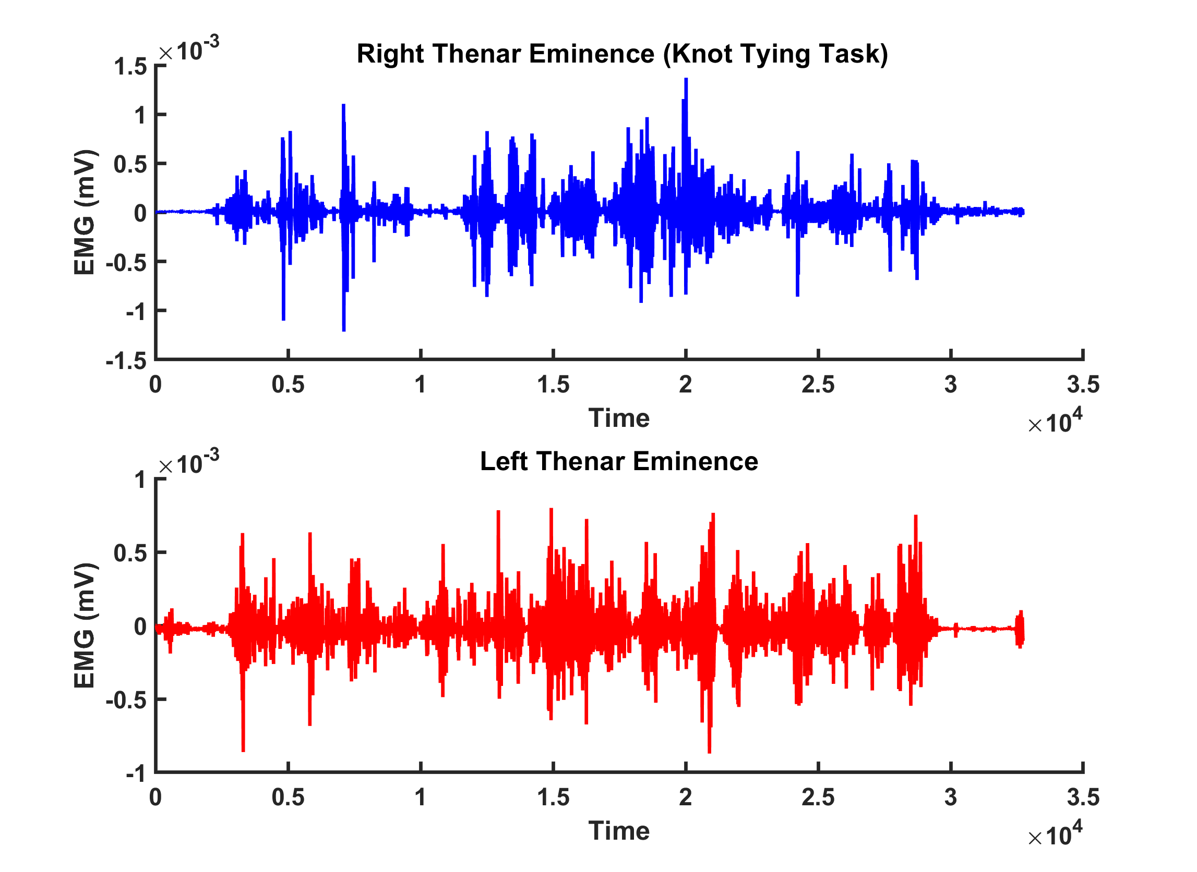

Figure 4. EMG waveforms from knot tying task

- Robotic Suturing:
Subjects suture a single surgeon’s knot followed by three single knots, forming two square knots.

- Ureteroscopy in a Kidney Model
This task utilizes a kidney model, and is broken up into three separate portions. 1) Accessing the bladder. 2) Advancing through the ureter. 3) Navigating to the upper, middle, and lower poles of the kidney. The kidney model and ureteroscope are depicted in figure 5 below.

EMG Data Analysis Model
Our EMG data is captured and analyzed in collaboration with a team from Chapman University in the Department of Physical Therapy, led by Dr. Rahul Soangra and Dr. Emmanuel John. The study utilizes Delsys Trigno wearable EMG devices, as well as Delsys EMGworks® software.

The EMG data analysis model utilized involves both previously utilized and novel approaches in computing economy of motion, as dictated below:

- A standard in EMG analysis: integrate EMG waveforms for summation of work done per muscle per second for a particular task. This “expenditure” is a commonly utilized metric for fatigue and economy of motion.
- A novel EMG analysis model of tracking co-contractions of antagonizing muscles while completing a particular task. The hypothesis is that increased co-contractions skew towards novices, as they indicate “unnecessary” over-activation of certain muscles, while minimal co-contractions could potentially be a hallmark of expertise.
- Multi-joint coordination of the upper limb will also be taken into consideration, under similar principles utilized for co-contractions of antagonistic muslces.
- Further, the analysis will take into consideration resultant magnitude of accelerometry data, with increased or decreased magnitude for a particular task correlating with economy of motion.

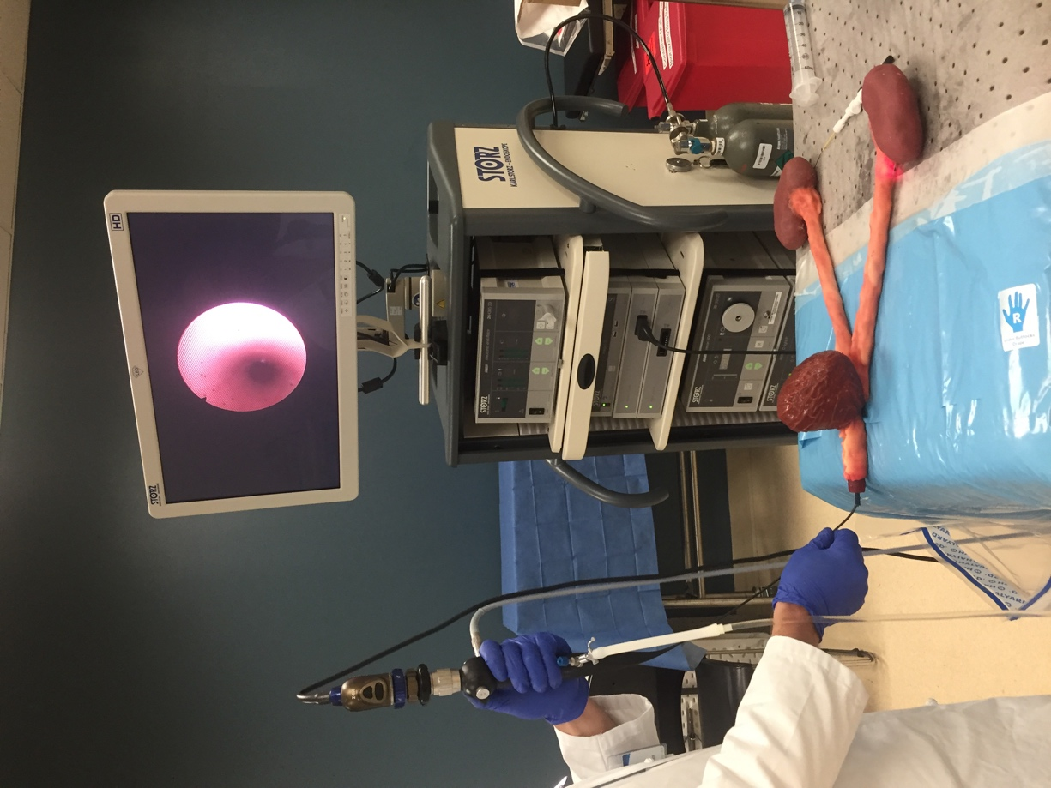

Figure 5. Ureteroscopy in Kidney Model

